***Case Study***: Shopping Cart

***Module***: Search

***Tech Stack***: Spring MVC, Hibernate, MVC, UI (Bootstrap/AngularJS / Spring Tiles/JQuery with HTML5)

Task: Create a shopping cart application module to demonstrate a shopping process

To do List:

1. The web page should be populated with existing records in the database
2. The product details to be displayed in tabular format with a field for entering the quantity required.
3. Another page should be displayed on click of add to cart for displaying the products in the cart.
4. The cart should have a provision to delete the items from it
5. The grand total has to be calculated according to the product purchase.

Screens:

Screen 1:

The table records has to be displayed as below.

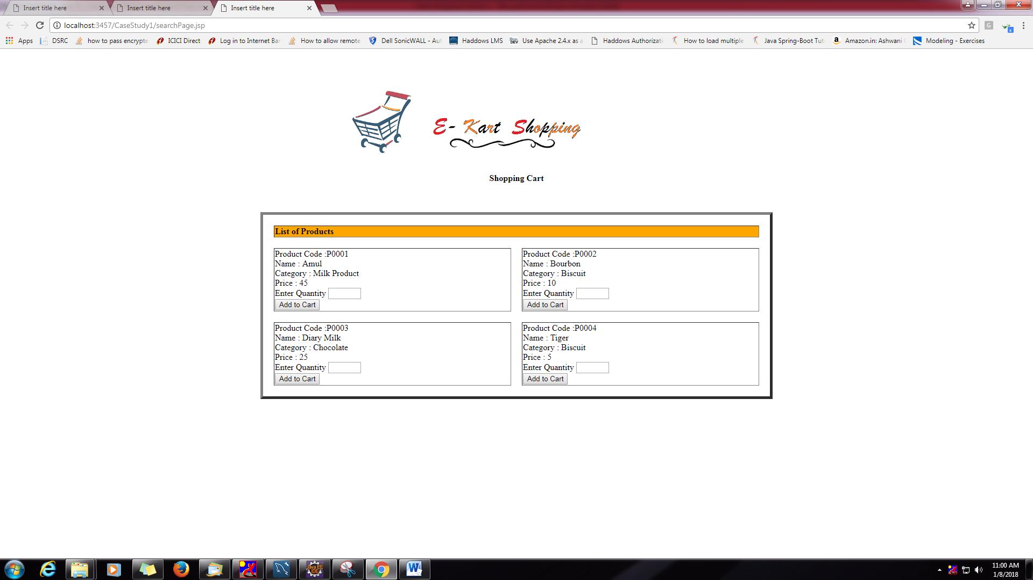

Screen2:

Cart Page

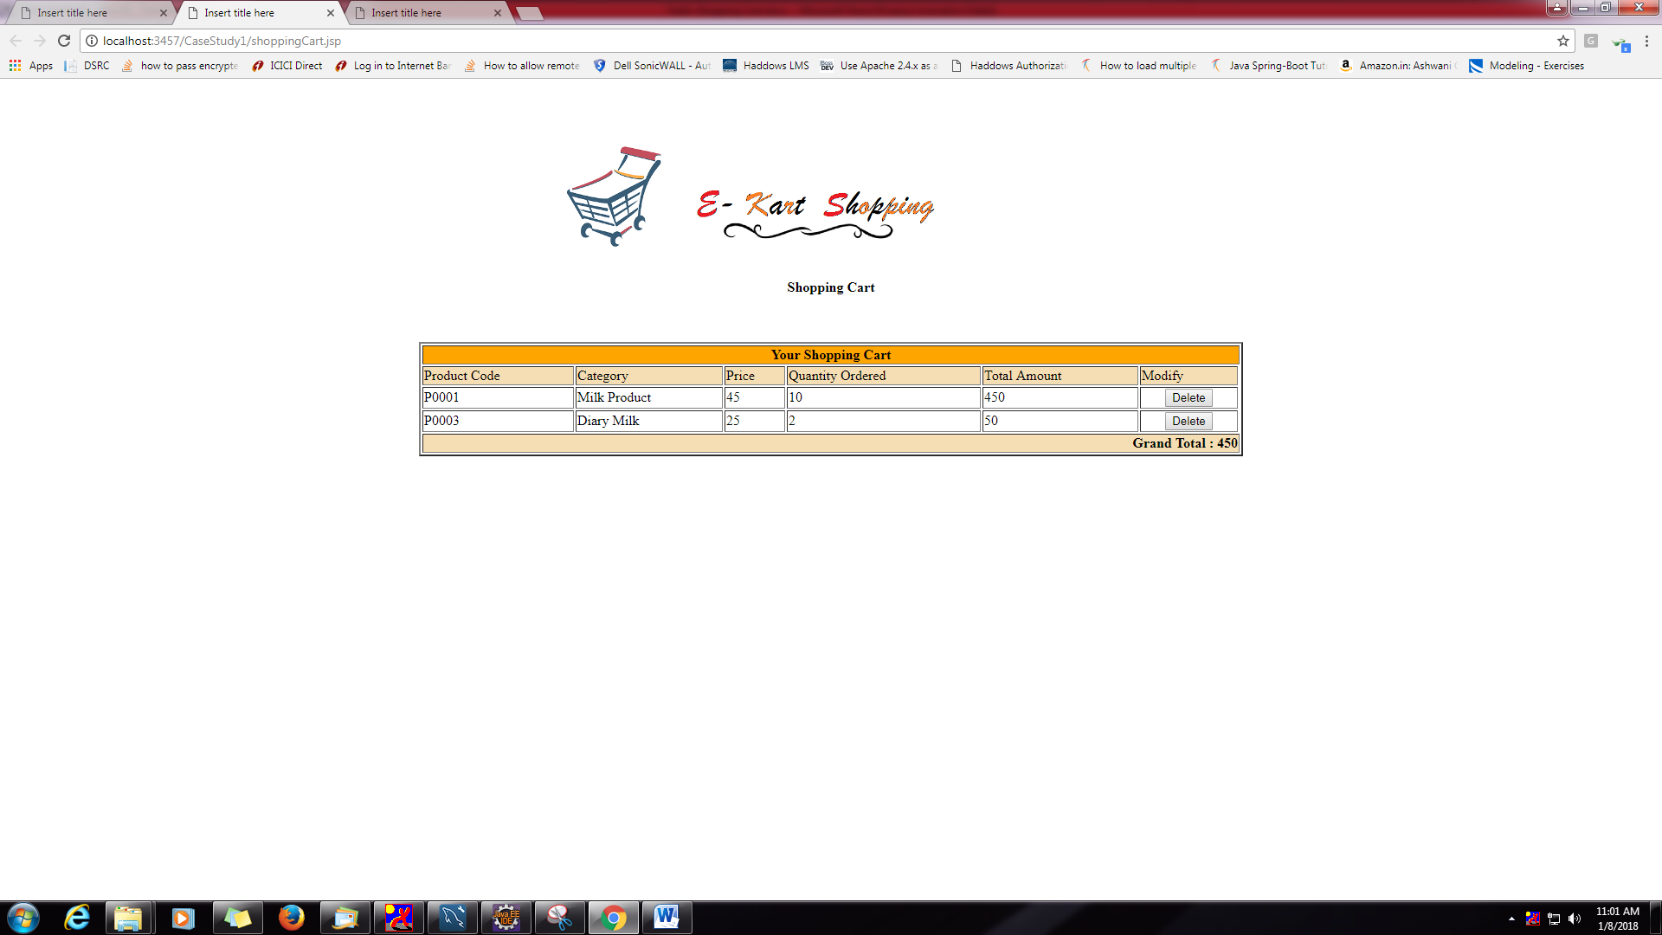

Database Design:

Table Design:

